Create the table name: Programmer

Field names

|  |  |
| --- | --- |
| **Attribute Name** | **Description** |
| Employeeid | Unique id, max 5 as number data |
| Projected | Max 3 |
| Firstname | Max 30 chars |
| Lastname | Max 30 chars |
| Hiredate | Date on which employee hired |
| Language | 15 char |
| Taskno | Number having 2 digits |
| Previlage | Max 25 length characters |

Your insert the data

|  |  |  |  |  |  |  |  |
| --- | --- | --- | --- | --- | --- | --- | --- |
| **employeeid** | **projectid** | **firstname** | **lastname** | **hiredate** | **language** | **taskno** | **previlage** |
| 201 | NPR | Savrav | Gupta | 1/1/95 | C++ | 21 | Secret |
| 390 | BLR | Pinky | Ghosh | 1/05/96 | C++ | 11 | Top Secret |
| 789 | PNE | Praveen | Agarwal | 08/31/99 | Java | 11 | Secret |
| 134 | CHN | Supriya | Chaudhury | 07/15/97 | VB | 22 | Top Secret |
| 896 | HYD | Ranjit | Jha | 06/15/98 | Java | 13 | Confidential |
| 345 | CHN | Peter | John | 11/15/99 | VB | 25 |  |
| 563 | BLR | Andy | Anderson | 03/15/14 | Java | 28 | Top Secret |

1. Display the name of programmer working in CHN project.
2. Display the programmer working in CHN project whose previlage is Top Secret.
3. Display the count of employees, working in BLR project
4. Display the project having minimum tasks.
5. Display the employees languages, that first name starts with ‘P’

SOLUTION:

Table Schema:

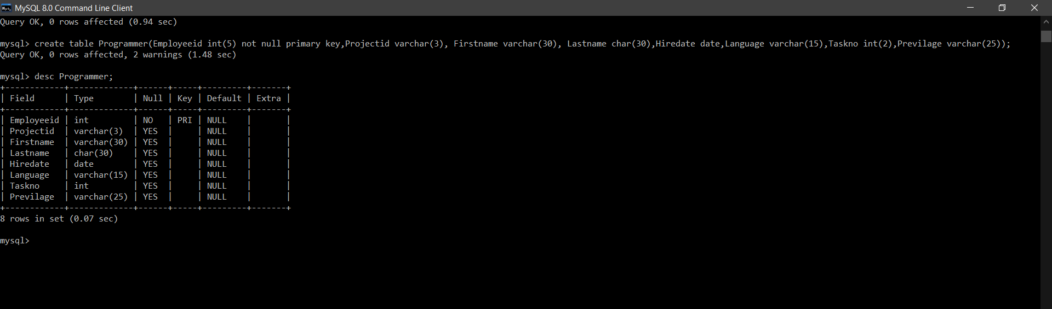

Display Table After Insert:

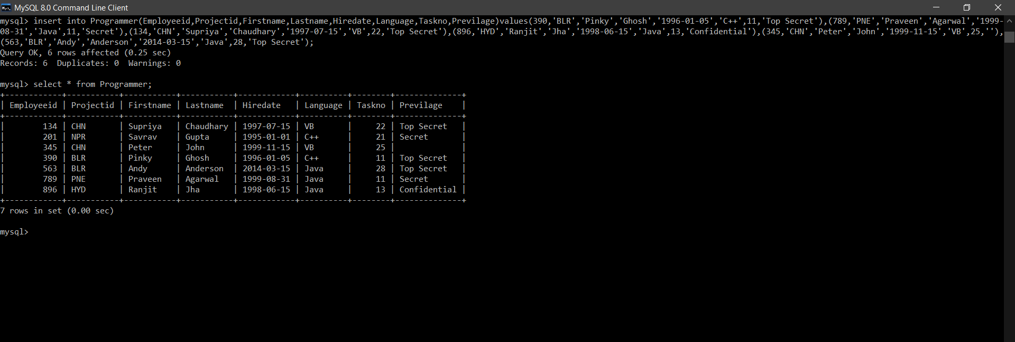

SQL Queries Solution:

1.

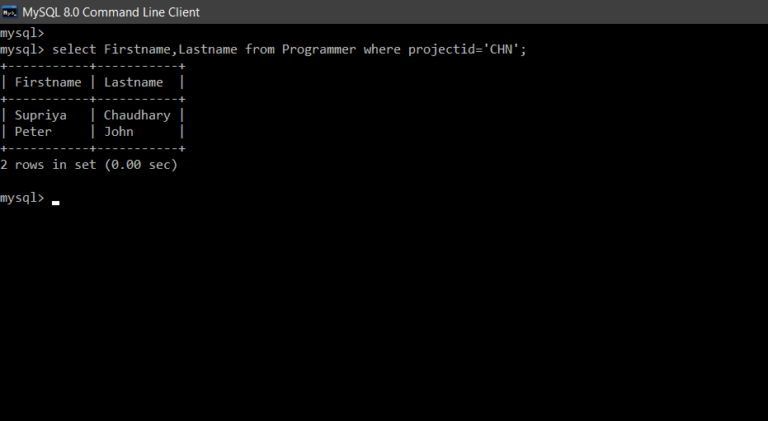

2.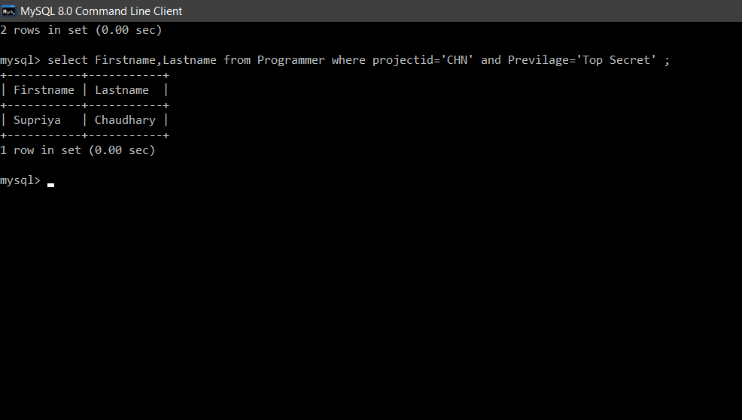

3.

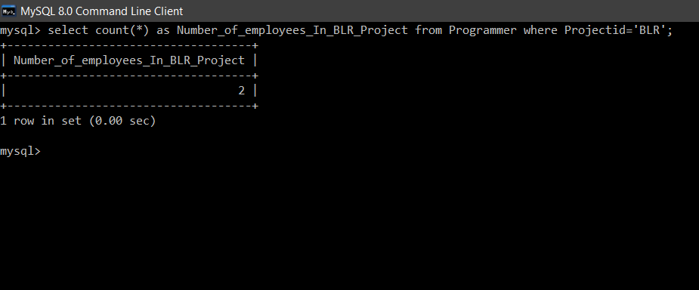

4.

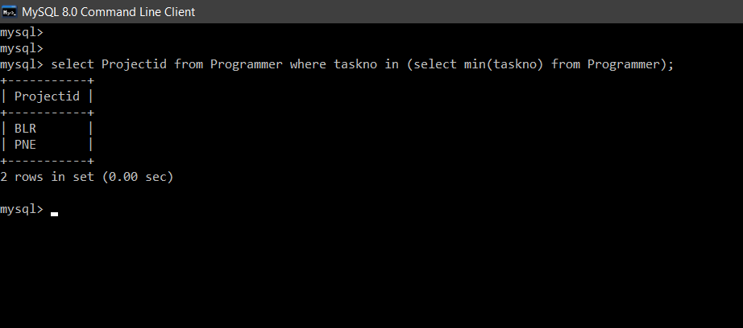

5.

